State of Michigan

OBRA Automation suite

Workflow-5

On Demand Print Assessment form & Comprehensive Level II

**Workflows with screenshots:**

Step 1:

CMH User logs in. Evaluations Module

Step 2:

Search for a consumer. Use the search criteria below. Last name = a,

Determination : Nursing facility specialized services, Determination date > 01/01/2021

Step 3:  
Results displayed below. Sort by descending order of Determination date. Click on the first record anywhere on that row.

Step 4:

Land on Evaluation Detail Completed page. Scroll down and click on “Psychosocial Form” hyper link

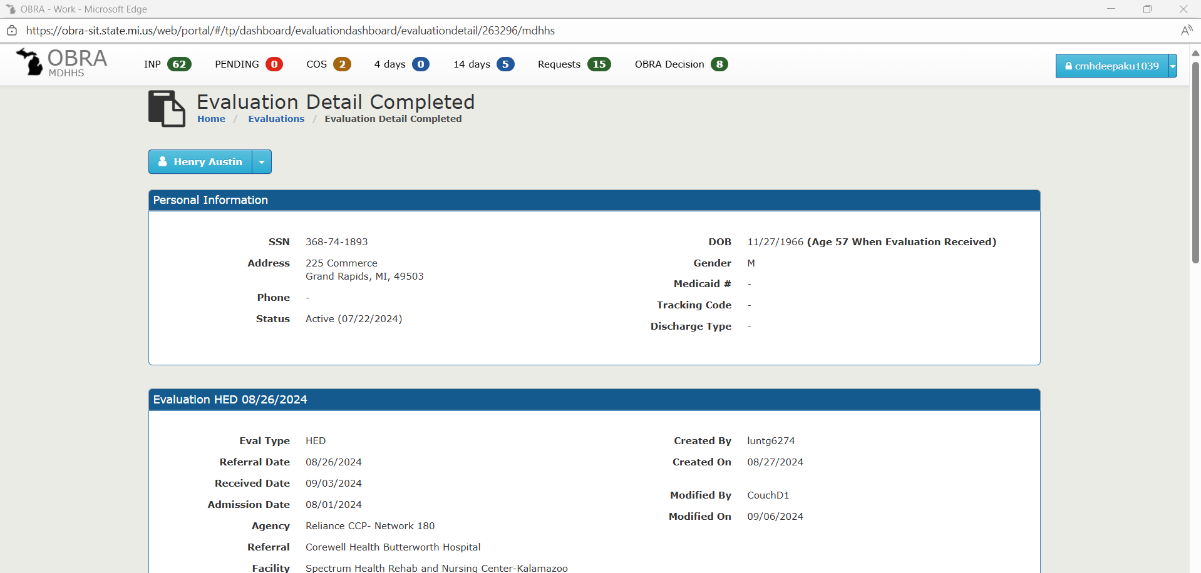

Step 5:

Psychosocial form opened in a new window. Click on “Print”. The print form should be captured and stored. 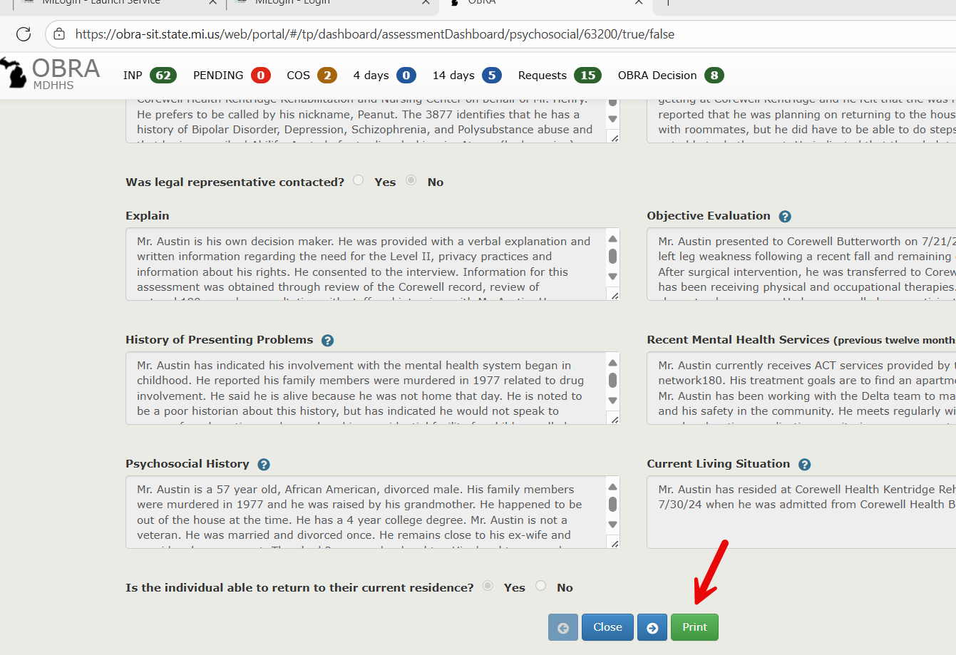

Step 6:

Navigate back to Evaluation Detail Completed Page. Click on Medical form. (Repeat the same steps as Psychosocial Form). The Medical form will be printed a new window, capture the first page.

Step 7:

Navigate back to 3877-78 Detail page, click on “View All”

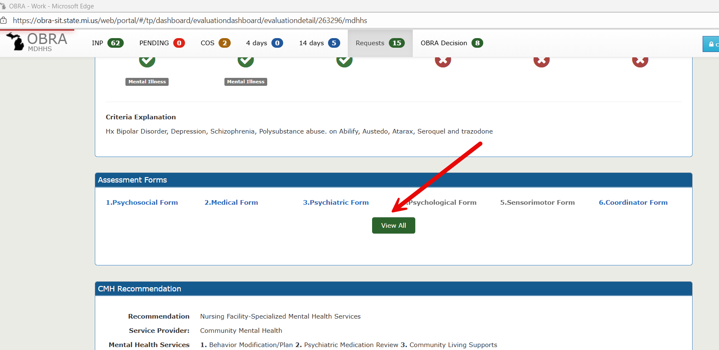

Step 8:

Capture the PDF printed.

Step 9:

Navigate back to 3877-78 Detail page, click on the drop down menu next to the Consumer name.

Step 10:

Capture the PDF Printed.